Define virtualization and its role in cloud computing:
Virtualization is technology that you can use to create virtual representations of servers, storage, networks, and other physical machines. Virtual software mimics the functions of physical hardware to run multiple virtual machines simultaneously on a single physical machine.
A virtual machine (VM) is a digital version of a physical computer. Virtual machine software can run programs and operating systems, store data, connect to networks, and do other computing functions, and requires maintenance such as updates and system monitoring.
Explain the relationship between virtualization and cloud computing:
see the difference between Cloud computing and Virtualization:-
S.NO | Cloud Computing | Virtualization
1. | Cloud computing is used to provide pools and automated resources that can be accessed on-demand. | While It is used to make various simulated environments through a physical hardware system.
2. | Cloud computing setup is tedious, complicated. | While virtualization setup is simple as compared to cloud computing.
3. | Cloud computing is high scalable. | While virtualization is low scalable compared to cloud computing.
4. | Cloud computing is Very flexible. | While virtualization is less flexible than cloud computing.
5. | In the condition of disaster recovery, cloud computing relies on multiple machines. | While it relies on single peripheral device.
6. | In cloud computing, the workload is stateless. | In virtualization, the workload is stateful.
7. | The total cost of cloud computing is higher than virtualization. | The total cost of virtualization is lower than Cloud Computing.
8. | Cloud computing requires many dedicated hardware. | While single dedicated hardware can do a great job in it.
9. | Cloud computing provides unlimited storage space. | While storage space depends on physical server capacity in virtualization.
10. | Cloud computing is of two types : Public cloud and Private cloud. | Virtualization is of two types : Hardware virtualization and Application virtualization.
11. | In Cloud Computing, Configuration is image based. | In Virtualization, Configuration is template based.
12. | In cloud computing, we utilize the entire server capacity and the entire servers are consolidated. | In Virtualization, the entire servers are on-demand.
13. | In cloud computing, the pricing pay as you go model, and consumption is the metric on which billing is done. | In Virtualization, the pricing is totally dependent on infrastructure costs.

History of Cloud Computing :
In this, we will discuss the history of Cloud computing. And also cover the history of client server computing, distributed computing, and cloud computing.
- Before Computing was come into existence, client Server Architecture was used where all the data and control of client resides in Server side. If a single user want to access some data, firstly user need to connect to the server and after that user will get appropriate access. But it has many disadvantages. So, After Client Server computing, Distributed Computing was come into existence, in this type of computing all computers are networked together with the help of this, user can share their resources when needed. It also has certain limitations. So in order to remove limitations faced in distributed system, cloud computing was emerged.
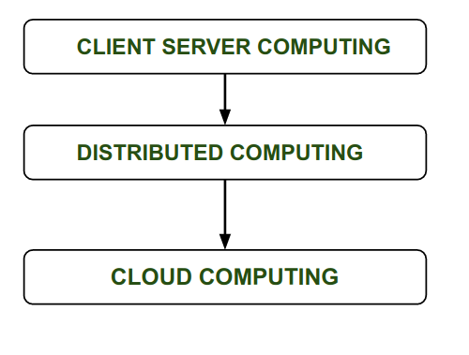
- During 1961, John MacCharty delivered his speech at MIT that “Computing Can be sold as a Utility, like Water and Electricity.” According to John MacCharty it was a brilliant idea. But people at that time don’t want to adopt this technology. They thought the technology they are using efficient enough for them. So, this concept of computing was not appreciated much so and very less will research on it. But as the time fleet the technology caught the idea after few years this idea is implemented. So, this is implemented by Salesforce.com in 1999.
- This company started delivering an enterprise application over the internet and this way the boom of Cloud Computing was started.
- In 2002, Amazon started Amazon Web Services (AWS), Amazon will provide storage, computation over the internet. In 2006 Amazon will launch Elastic Compute Cloud Commercial Service which is open for Everybody to use.
- After that in 2009, Google Play also started providing Cloud Computing Enterprise Application as other companies will see the emergence of cloud Computing they also started providing their cloud services. Thus, in 2009, Microsoft launch Microsoft Azure and after that other companies like Alibaba, IBM, Oracle, HP also introduces their Cloud Services. In today the Cloud Computing become very popular and important skill.
Advantages :
- It is easier to get backup in cloud.
- It allows us easy and quick access stored information anywhere and anytime.
- It allows us to access data via mobile.
- It reduces both hardware ad Software cost, and it is easily maintainable.
- One of the biggest advantage of Cloud Computing is Database Security.
Disadvantages :
- It requires good internet connection.
- User have limited control on the data.
Identify and describe the key components involved in building cloud computing environments

Cloud Computing Architecture and Components
By :Richard Peterson
UpdatedDecember 5, 2023

What is Cloud Computing Architecture?
Cloud Computing Architecture is a combination of components required for a Cloud Computing service. A Cloud computing architecture consists of several components like a frontend platform, a backend platform or servers, a network or Internet service, and a cloud-based delivery service.
Let’s have a look into Cloud Computing and see what Cloud Computing is made of. Cloud computing comprises two components, the front end, and the back end. The front end consists of the client part of a cloud computing system. It comprises interfaces and applications that are required to access the Cloud computing or Cloud programming platform.
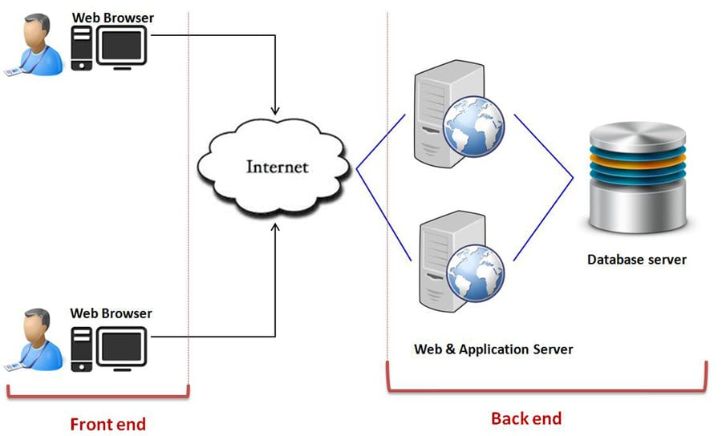Cloud Computing Architecture
While the back end refers to the cloud itself, it comprises the resources required for cloud computing services. It consists of virtual machines, servers, data storage, security mechanisms, etc. It is under the provider’s control.
Cloud computing distributes the file system that spreads over multiple hard disks and machines. Data is never stored in one place, and in case one unit fails, the other will take over automatically. The user disk space is allocated on the distributed file system, while another important component is an algorithm for resource allocation. Cloud computing is a strong distributed environment, and it heavily depends upon strong algorithms.
Important Linux Commands for Beginners Linux Tutorial15:03

Cloud Computing Architecture
The Architecture of Cloud computing contains many different components. It includes Client infrastructure, applications, services, runtime clouds, storage spaces, management, and security. These are all the parts of a Cloud computing architecture.
Front End:
The client uses the front end, which contains a client-side interface and application. Both of these components are important to access the Cloud computing platform. The front end includes web servers (Chrome, Firefox, Opera, etc.), clients, and mobile devices.
Back End:
The backend part helps you manage all the resources needed to provide Cloud computing services. This Cloud architecture part includes a security mechanism, a large amount of data storage, servers, virtual machines, traffic control mechanisms, etc.
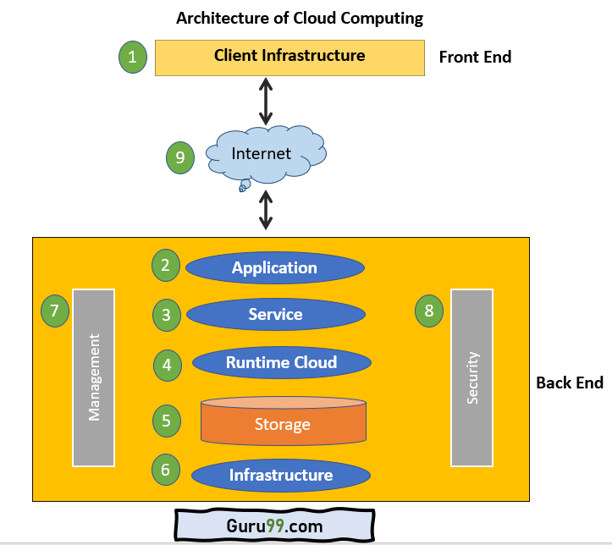Cloud Computing Architecture Diagram

Important Components of Cloud Computing Architecture
Here are some important components of Cloud computing architecture:

1. Client Infrastructure
Client Infrastructure is a front-end component that provides a GUI. It helps users to interact with the Cloud.

2. Application
The application can be any software or platform which a client wants to access.

3. Service
The service component manages which type of service you can access according to the client’s requirements.
Three Cloud computing services are:
- Software as a Service (SaaS)
- Platform as a Service (PaaS)
- Infrastructure as a Service (IaaS)

4. Runtime Cloud
Runtime cloud offers the execution and runtime environment to the virtual machines.

5. Storage
Storage is another important Cloud computing architecture component. It provides a large amount of storage capacity in the Cloud to store and manage data.

6. Infrastructure
It offers services on the host level, network level, and application level. Cloud infrastructure includes hardware and software components like servers, storage, network devices, virtualization software, and various other storage resources that are needed to support the cloud computing model.

7. Management
This component manages components like application, service, runtime cloud, storage, infrastructure, and other security matters in the backend. It also establishes coordination between them.

8. Security
Security in the backend refers to implementing different security mechanisms for secure Cloud systems, resources, files, and infrastructure to the end-user.

9. Internet
Internet connection acts as the bridge or medium between frontend and backend. It allows you to establish the interaction and communication between the frontend and backend.

Benefits of Cloud Computing Architecture
Following are the cloud computing architecture benefits:
- Makes the overall Cloud computing system simpler.
- Helps to enhance your data processing.
- Provides high security.
- It has better disaster recovery.
- Offers good user accessibility.
- Significantly reduces IT operating costs.

Virtualization and Cloud Computing
The main enabling technology for Cloud Computing is Virtualization. Virtualization is the partitioning of a single physical server into multiple logical servers. Once the physical server is divided, each logical server behaves like a physical server and can run an operating system and applications independently. Many popular companies like VMware and Microsoft provide virtualization services. Instead of using your PC for storage and computation, you can use their virtual servers. They are fast, cost-effective, and less time-consuming.
For software developers and testers, virtualization comes in very handy. It allows developers to write code that runs in many different environments for testing.
Virtualization is mainly used for three main purposes: 1) Network Virtualization, 2) Server Virtualization, and 3) Storage Virtualization
Network Virtualization: It is a method of combining the available resources in a network by splitting up the available bandwidth into channels. Each channel is independent of others and can be assigned to a specific server or device in real time.
Storage Virtualization: It is the pooling of physical storage from multiple network storage devices into what appears to be a single storage device that is managed from a central console. Storage virtualization is commonly used in storage area networks (SANs).
Server Virtualization: Server virtualization is the masking of server resources like processors, RAM, operating system, etc., from server users. Server virtualization intends to increase resource sharing and reduce the burden and complexity of computation from users.
Virtualization is the key to unlock the Cloud system, what makes virtualization so important for the cloud is that it decouples the software from the hardware. For example, PCs can use virtual memory to borrow extra memory from the hard disk.
TAXONOMY OF VIRTUALIZATION TECHNIQUES

Virtualization covers a wide range of emulation techniques that are appliedto different areas of computing.

A classification of these techniques helps us better understand theircharacteristics and use .

The first classification discriminates against the service or entity that isbeing emulated.

Virtualization is mainly used to emulate
execution environments,storage, and networks.


Among these categories,
execution virtualization
constitutes the oldest,most popular, and most developed area. Therefore, it deserves majorinvestigation and a further categorization
.
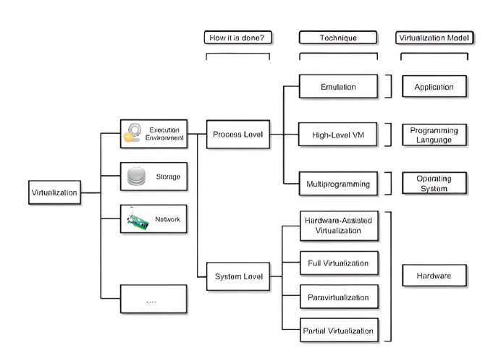

Open challenges in cloud computing
Cloud is an important resource with its various benefits, but it has various risks and challenges as well. This article will dive deep into a few of the most common cloud computing challenges faced by the industry, cloud security challenges and risks, and cliched cloud computing problems and solutions.
The top 11 cloud computing challenges are:
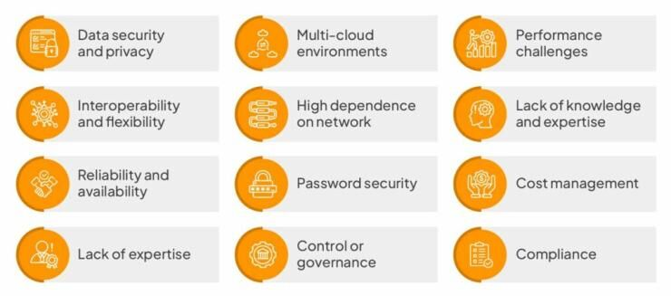

Data security and privacy
When working with Cloud environments, data security is a major concern as users have to take responsibility for their data, and not all Cloud providers can assure 100% data privacy.
No identity access management, lack of visibility and control tools, data misuse, and cloud misconfiguration are the common reasons behind cloud privacy leaks. There are also concerns about malicious insiders, insecure APIs, and neglect or oversights in cloud data management.

Solution:
Install and implement the latest software updates, as well as configure network hardware to prevent security vulnerabilities. Using antivirus and firewalls, increasing bandwidth for Cloud data availability, and implementing cybersecurity solutions are some ways to prevent data security risks.

Multi-cloud environments
Multi-cloud environments present issues and challenges such as – configuration errors, data governance, lack of security patches, and no granularity. It is difficult to apply data management policies across various boards while tracking the security requirements of multi-clouds.

Solution:
Implementing a multi-cloud data management solution can help you manage multi-cloud environments. We should be careful while choosing the solution, as not all tools offer specific security functionalities, and multi-cloud environments continue to become highly sophisticated and complex.

Performance challenges
The performance and security of cloud computing solutions depend on the vendors, and keep in mind that if a Cloud vendor goes down, you may lose your data too.

Solution:
Cloud Service Providers should have real-time SaaS monitoring policies.

Interoperability and flexibility
when you try to shift applications between two or multiple Cloud ecosystems, interoperability is a challenge. Some of the most common issues are:
- Match the target cloud environment’s specifications by rebuilding application stacks
- Managing services and apps in the target cloud ecosystem
- Working with data encryption during migration
- Configuring networks in the target cloud for operations

Solution:
Before starting work on projects, setting Cloud interoperability as well as portability standards can help organizations solve this problem. The use of multi-layer authorization and authentication tools is a good choice for account verifications in hybrid, public, and private cloud ecosystems.

High dependence on network
When transferring large volumes of information between Cloud data servers, a lack of sufficient internet bandwidth is a common problem. There is a risk of sudden outages, and data is highly vulnerable. To help prevent business losses from sudden outages, enterprises should ensure there is high bandwidth without sacrificing performance.

Solution:
Focus on improving operational efficiency and pay more for higher bandwidth to address network dependencies.

Lack of knowledge and expertise
Hiring the right Cloud talent is another common challenge in cloud computing. There is a shortage of working security professionals with the necessary qualifications in the industry. As the workloads are increasing, so are the number of tools launched in the market. Enterprises need good expertise in order to efficiently utilize these tools and look out for the best fit.

Solution:
Hire Cloud professionals having specializations in DevOps as well as automation.

Reliability and availability
High unavailability of Cloud services, as well as lack of reliability, are the major concerns in these ecosystems. In order to keep up with ever-changing business requirements, businesses are forced to seek additional computing resources.
If a Cloud vendor gets hacked, the sensitive data of organizations using their services gets compromised.

Solution:
Improve both aspects by implementing the NIST Framework standards in Cloud environments.

Password security
Account managers manage all their cloud accounts using the same passwords. Password management poses a critical problem, and it is often found that users resort to using weak and reused passwords.

Solution:
Secure all your accounts by using a strong password management solution. To further improve security, in addition to a password manager, use Multifactor Authentication (MFA). Cloud-based password managers should alert users of security risks and leaks.

Cost management
Although Cloud Service Providers (CSPs) offer a pay-as-you-go subscription model for services, hidden costs are charged as underutilized resources in enterprises, making the costs can add up.

Solution:
Implementing resource utilization monitoring tools as well as auditing systems regularly are some ways organizations can fix this. It’s one of the most efficient methods to deal with major challenges and manage budgets in cloud computing.

Lack of expertise
Cloud computing is a highly competitive field, and there are many professionals who lack the required knowledge and skills to be employed in the industry. There is also a huge gap in supply and demand for certified individuals and many job vacancies.

Solution:
Companies should help existing IT staff in upskilling their careers and skills by investing in Cloud training programs.

Control or governance
Good IT governance makes sure that the right tools are used and assets get implemented as per procedures and agreed-on policies. Lack of governance is a common problem in cloud computing, and companies utilize tools that do not align with their vision. IT teams don’t get total control of compliance, data quality checks, and risk management, thus creating many uncertainties when migrating to the cloud from traditional infrastructures.

Solution:
Traditional IT operations should be adopted to accommodate Cloud migrations.

Compliance
When it comes to having the best data compliance policies, cloud Service Providers (CSP) are not up-to-date. Organizations run into compliance issues with state laws and regulations whenever a user transfers data from internal servers to the cloud.

Solution
The General Data Protection Regulation Act is expected to address compliance issues in the future for CSPs.
.

